LAB ASSIGNMENT V : HUERISTIC EVALUATION
SYSTEM EVALUATED : The Daily Brief high-fidelity prototype (homepage, desktop)
Groups members NAME : Aditya Chavan.
**Evaluation to be done by other Group
PART I : HUERISTIC EVALUATION BASED ON NIELSEN'S 10 GENERAL PRINCIPLES FOR INTERACTION DESIGN. (0 is lowest and 10 is highest)
S.No. | Heuristic Evaluation Parameter | Mention Violation if any | Severity 0-10 (0 = minimum, 10 = maximum) | Ways to improve
1 | User Control: Interface will allow the user to perceive that they are in control | Header stays put and there's a dark mode switch, so I felt in control. But I couldn't close the LIVE strip. | 2 | Let people dismiss the LIVE strip.
2 | Human Limitations: Interface will not overload the users cognitive, auditory and motor skills | Clean page, but the same four photos repeat in every row, so scanning gets tiring. | 3 | Use different photos for different stories.
3 | Accommodation: The interface will fit the way each user group works and thinks (personas) | For You, My City and Personalize show it adapts to the reader. City looks pre-set to Bengaluru. | 2 | Ask for the city on the first visit.
4 | Linguistic Clarity: Interface will communicate as efficiently as possible | Labels are clear, but "Newsletter" and "Subscribe" sit side by side and may confuse. | 3 | Merge them or explain the difference.
5 | Aesthetic Integrity :The interface will have an attractive and appropriate design | Navy and serif headlines look trustworthy, but the repeated stock images feel fake. | 4 | Match each photo to its story.
6 | Simplicity: The interface will have a simple design | Only 8 menu items and lots of white space. Very easy to take in. | 1 | Keep it this simple.
7 | Predictability :The interface will behave in such a manner that the user can accurately predict what will happen next | View all, More stories and Personalize arrows behave as expected. The floating buttons sit over the cards. | 2 | Move the floating buttons away from content.
8 | Accuracy: Interface will be free from errors | Placeholder text shows: "970 x 250 reserved ad space", and every card says "24 mins ago" with the same filler line. | 4 | Use real timestamps and real summaries.
9 | Technical Clarity: Interface will have the highest possible fidelity. | Sharp and polished, but the placeholder text and repeated images show it isn't fully real yet. | 3 | Replace all placeholder content.
10 | Fulfillment : The interface will provide a satisfying user experience | Calm, quick to scan and pleasant to scroll. Nothing felt pushy. | 2 | Add a bit more variety in layouts.
11 | Consistency: Interface will be consistent | Cards, tags, buttons and fonts look the same everywhere. | 1 | Keep using the same card style.
12 | User Support: Interface will provide additional assistance as needed or requested | A help (?) button is there, but I couldn't see what it opens. Unsubscribe note is a nice touch. | 3 | Show a short help tip on first visit.
13 | Precision: The interface will allow the users to perform a task exactly | Small text links like View all are easy to miss. Menu and search weren't opened in the recording. | 3 | Make small links bigger.
14 | Forgiveness: Interface will make action recoverable | No undo or confirmation was shown. Newsletter form has only a short privacy note. | 3 | Add a success message after subscribing.
15 | Responsiveness: The interface will inform users about the results of their actions and their interface status | No loading states or click feedback shown. The ad box is just a gray block. | 4 | Show skeleton loaders and a click response.
 | Total Score | Overall: clean and calm. Fix repeated images and placeholder text. | 40 / 150

**Attach Screenshots
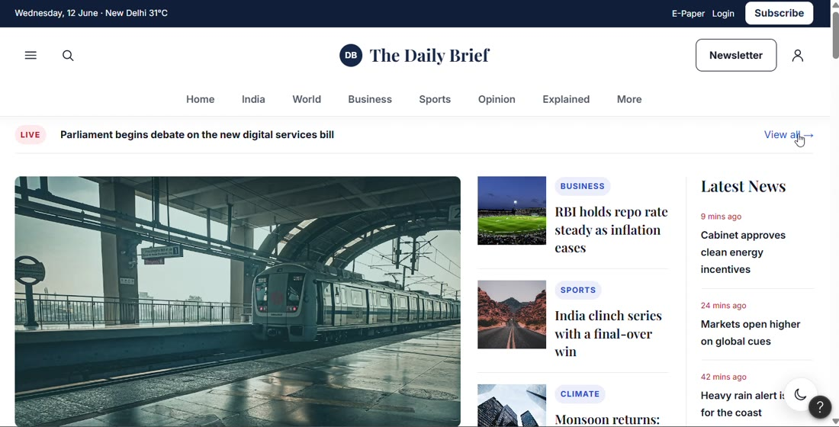
Figure 1: Header, LIVE strip, lead story and Latest News.
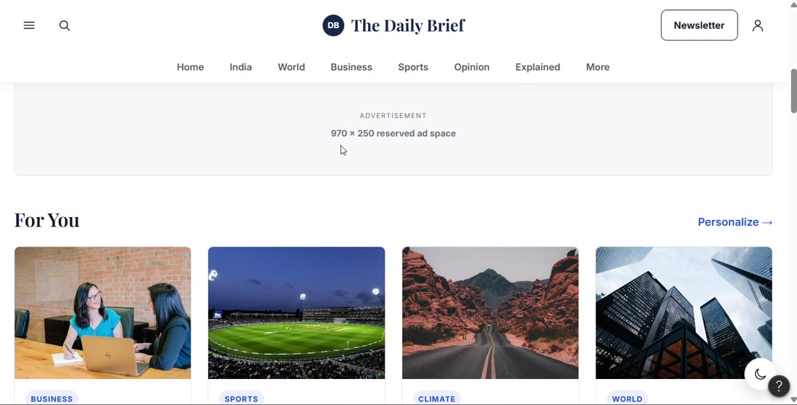
Figure 2: Reserved ad space and the For You row.
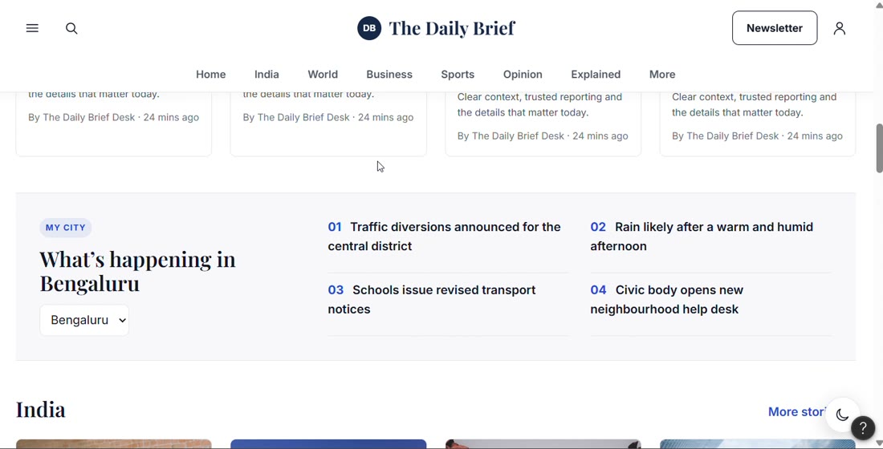
Figure 3: My City section with a city dropdown.
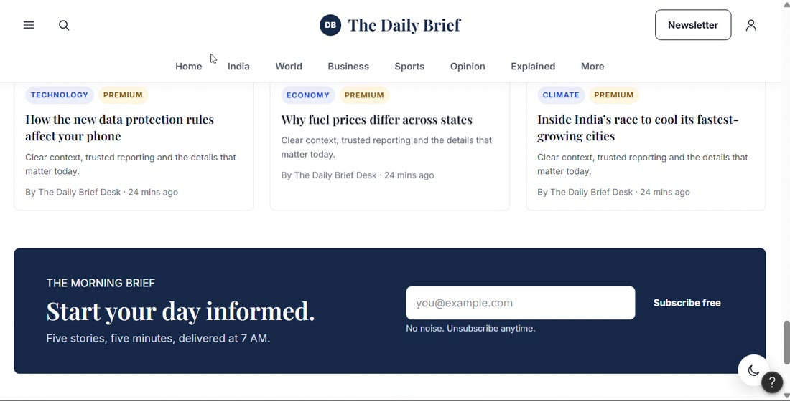
Figure 4: Newsletter banner at the end of the page.

PART II : List out any other points that you may have missed out . (Other than Nielsen’s Principles)

S.NO | OBSERVATIONS | COMMENTS
1 | The same four photos repeat in every section, even for different stories. | Looks fake and makes scanning harder. Use a different image per story.
2 | The ad slot is clearly labelled and its space is reserved, so nothing jumps. | Good idea. Just replace the placeholder text with a real ad or loader.
3 | Dark mode and help buttons float at the bottom right and cover card corners. | Move them or make them smaller so they don't block content.
4 | Header has both Newsletter and Subscribe, and the page ends with another signup banner. | Too many similar buttons. Pick one clear main action.
5 | The recording only shows the homepage scroll. | Menu, search, article, paywall and mobile still need testing.

Students Evaluation Team : group that is evaluation ………………………………………………………………………………..

